**SOLANO COMMUNITY COLLEGE**

**MT 162, ROBOTICS**

Fall, 2018

SOLANO COMMUNITY COLLEGE

ROBOTIC SYSTEMS MT-162

**LAB 5: MOTION INSTRUCTION PROGRAMMING**

**Catharine Crayne**

**10/22/18**

**OBJECTIVE**:

1. To learn how to create, teach, test, and execute a motion program that use various types of instructions.

**Group Members**

Diane

**MATERIALS**: RoboGuide and Laptop, Fanuc Robot, Box

**PROCEDURE**:

1. Power up the robot controller. Place the robot in Teach Mode.
2. Turn on Teach Pendant and change the robot’s jog speed to 25%. Set the robot to jog in the TOOL coordinate system.
3. Set the active Frames to Tool 2 and User 0. Remember [SHIFT] + [COORD].
4. Verify Tool Frame 2 is taught correctly by Jogging the robot in TOOL, yaW, Pitch, and Roll. If it is not correct, re-teach it.
5. Set the robot to jog in JOINT coordinates.
6. Create 2 new Position Registers, HOME and SAFE.
7. Jog the robot to a HOME joint position (or close to it). Use the [DATA] key and record the position into a PR.
8. Give the PR a comment “HOME”.
9. Now jog the robot to a SAFE position off to the side. Record this position into another P and comment it with “SAFE”.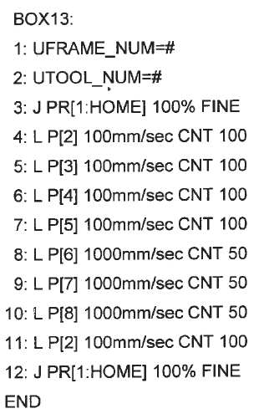
10. Create a new program, “BoxLab5YourName”.
11. Include the USER Frame and TOOL Frame info in the first couple of lines.
12. Have the program go to the HOME PR position with a Joint move.
13. Then teach another simple path that goes from the HOME PR….. outlines a box shape on the table, then returns back to HOME. See example to the right..
14. Test your program in STEP mode.
15. Now test the program in continuous mode.
16. Modify the path of the motion to include another small square as shown using L P[ ] 200mm/sec CNT 50 instructions.
17. Test your program in STEP mode.
18. Now test the program in continuous mode.
19. Now turn off the Teach Pendant, set the Operator Panel to AUTO, and run your program in AUTO mode.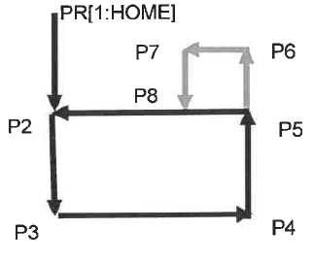

**RESULTS - DATA**

No Procedure questions were included in this lab.

**OBSERVATIONS**

Step 9 Step 10

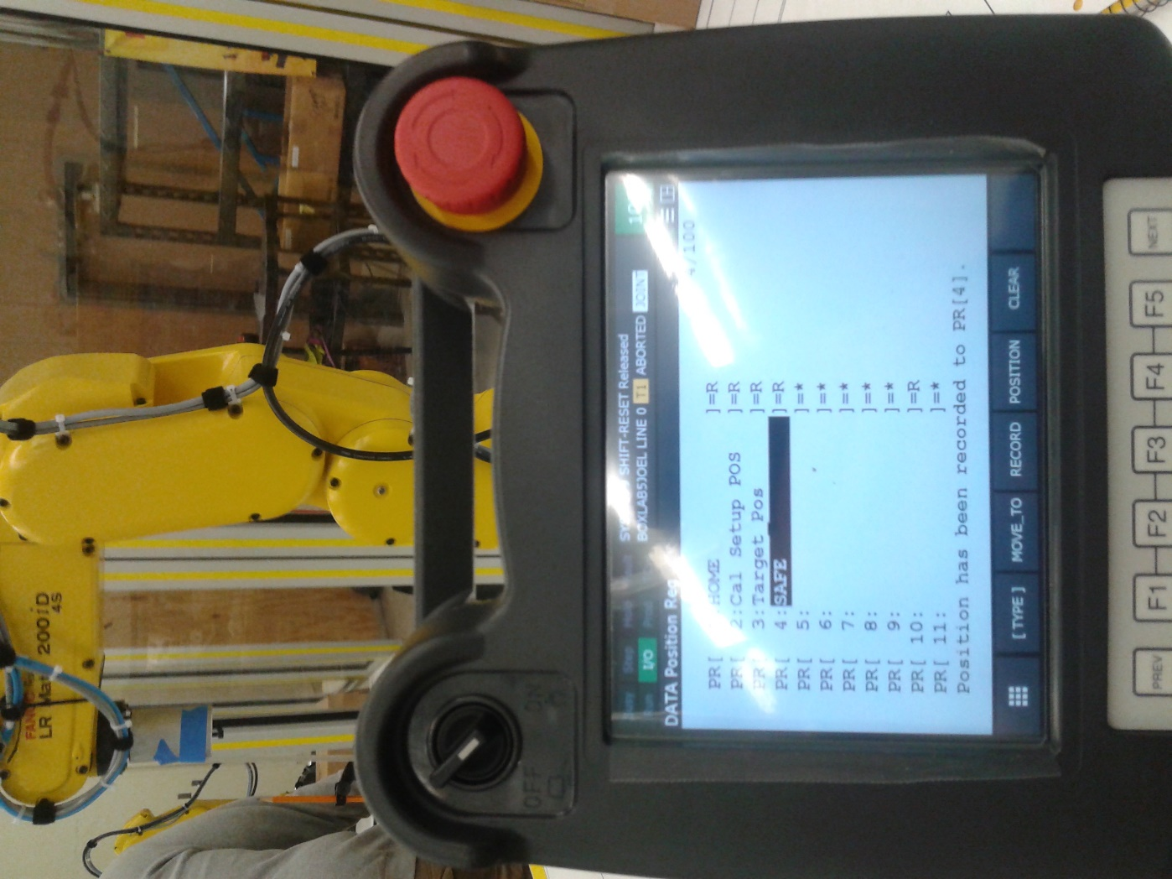 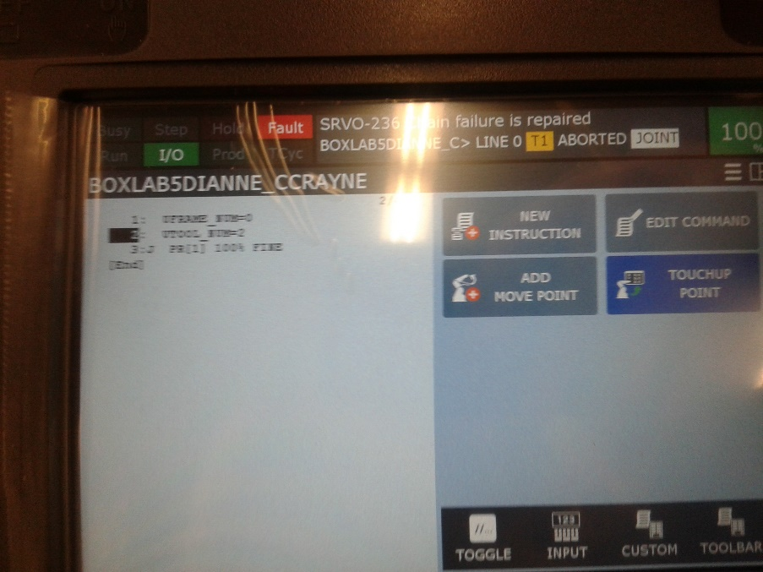

Step 11 Step 11

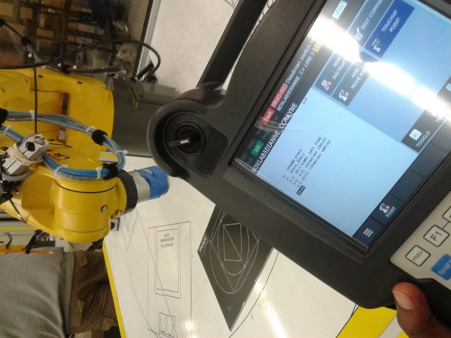 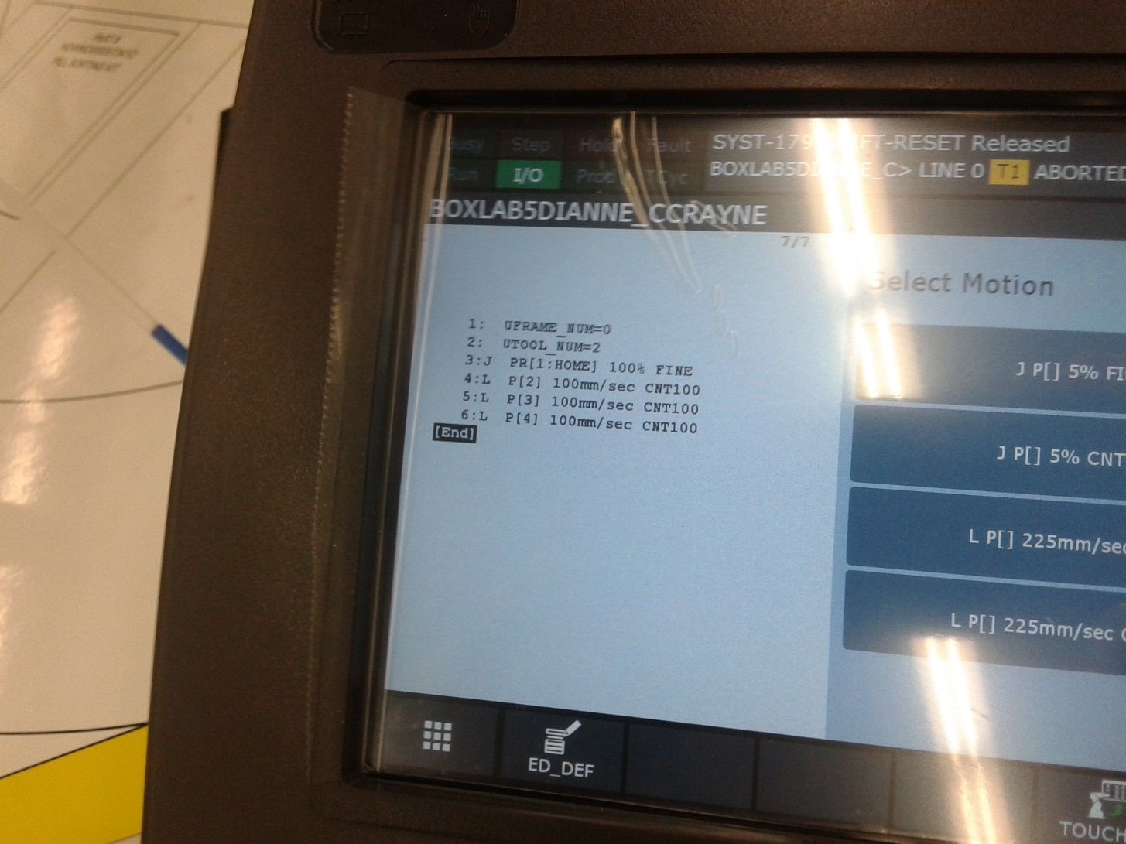

Step 12-16

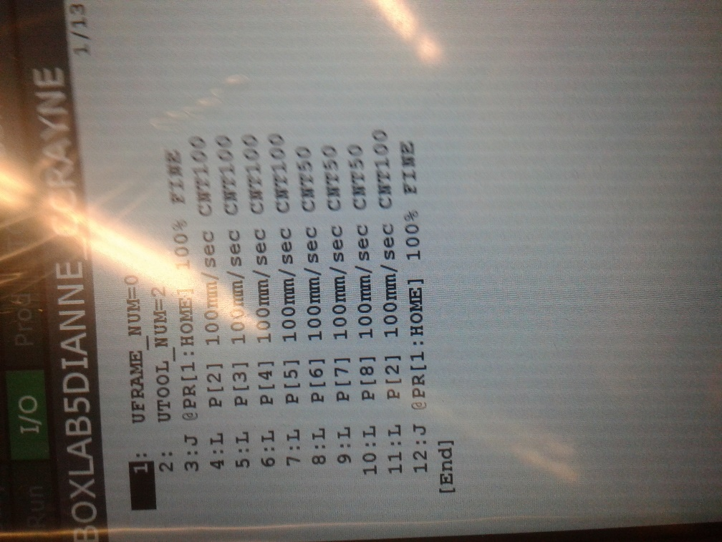

**Analysis Questions:**

1. What combination of keys are used to record a position?

*[SHIFT] + [Record]*

1. How is FINE termination type differ from CNT termination type?

*FINE stops at each point, and Continuous (CNT) keeps going in a fluid motion.*

1. What status symbol is used to indicate that the robot is currently at the taught position?

*@*

1. How is Position Register data different than just Position data?

*Position Register data is a global position which can be used across programs, whereas Position data is a position point which can only be called/used in the program in which it was created.*